DSA 0136 OBJECT ORIENTED PROGRAMMING USING C++

14)Write a c++ program for swapping of two numbers using call by value and call by reference

CALL BY REFERENCE

using namespace std;

#include<iostream>

int swap(int \*x,int \*y)

{

int \*temp;

temp=x;

x=y;

y=temp;

cout<<"x is"<< \*x;

cout<<"y is "<<\*y;

return 0;

}

int main()

{

int x,y;

cout<<"enter values of x and y";

cin>>x>>y;

swap(&x,&y);

return 0;

}

Output:

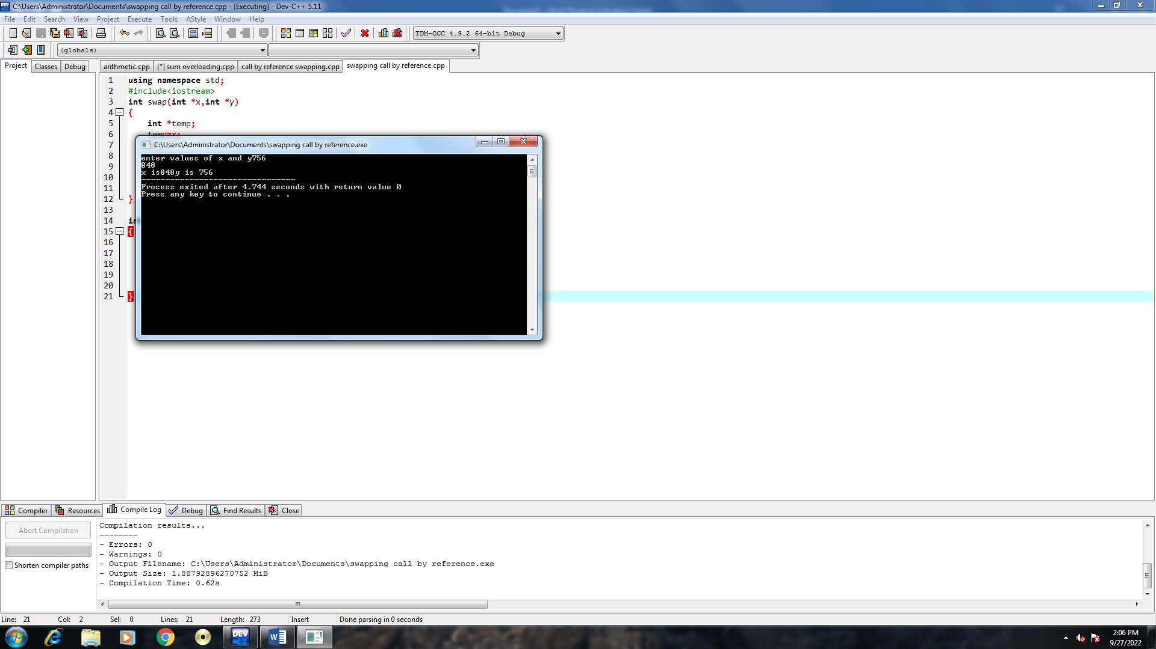

CALL BY VALUE